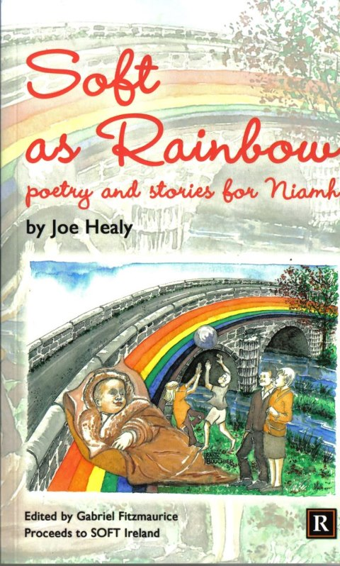
Soft as Rainbow’ - A Book of Poetry and Stories by Joe Healy will be launched at Arás Ide Resource Centre, Kilmeedy, Co. Limerick by Jerome Scanlan, Cathaoirleach, Limerick County Council on Friday, May 3rd 2013 at 8.30pm . MC is Eileen Sheehan. Cover Art by Frank Bouchier

